Mobile Cross Platform Apps - Titanium, Cordova, PhoneGap, Xamarin, React-Native, Ionic

Desktop Cross Platform Apps - Electron, Haxe, Xojo, Enyo, nwjs

Xamarin and React Native vs Sencha UI, JQuery Mobile

Building on top of web technologies is advantageous, but you still have to build separate UIs for each OS to match their look and feel.

## Speakers:

**Speaker 1:**



Madhu Rakhal Magar

Senior Software Engineer, CloudFactory

Topic: Functional Programming in JavaScript

**Speaker 2:**

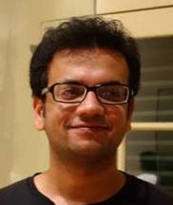

Pratik Gautam

Software Developer, Kathmandu Living Labs

Topic: Make data actionable using Open Mapping Technologies

*We find a lot of data every day, we create a lot of data every day. Almost all of these data have actionable information embedded in them, but we miss out on a lot of actionables when we see data outside of a larger context. Open Mapping Technologies, for instance OpenStreetMap, helps to put this data into context, transforming it into actionable information. This actionable information can have a variety of impacts: from helping you plan your next trekking vacation to facilitating/speeding up logistic planning during crisis. This presentation aims to demonstrate some of the instances in which the Open Mapping Stack and OpenStreetMap have been used to draw actionables from seemingly unrelated data.*

## Panelists:



Name: Aayush Shrestha

Description: Head of UI / UX Architecture and Design at Viveka Health & Co-Founder of Lishn

If there's anyone who can tell you about the difference between building a native app and a hybrid app using HTML technologies, its Aayush.

Question:

You’ve helped build Lishn, a native Android app and nLocate, a hybrid app. Web developers who traditionally had to stick with web apps now have the power to build mobile apps using the technologies they already know. What are the mistakes web developers trying to enter the mobile space through hybrid apps need to avoid?



Name: Subash Pathak

Description: Creater of Prepros App and few other things made of js

Long Description:Hear what the creator of prepros.io has to say about his experience building a cross-platform desktop app at KTMJS.

Question: Was prepros a cross platform app right from the start? If no, what was the main reason for going for electron? If yes, what were the main reasons for shifting to cross platform development?   
  
What future do you see for cross-browser app development on the Desktop?



Name: Anish Shrestha

cofounder and CEO, FawesomeApps, YellowNepal

Long Description: Software engineer by profession, he has more than 6 years of experience in application development, currently a runs a small IT venture. Anish is passionate about technology and a believer in changing the world with it.

Question: You’ve done a lot of product related work. A lot of blood, sweat and energy goes into building a product.  
  
Do you think in the near future, more companies will look into going into the market with a cross-platform app and then moving to native apps once you’ve tested the waters?

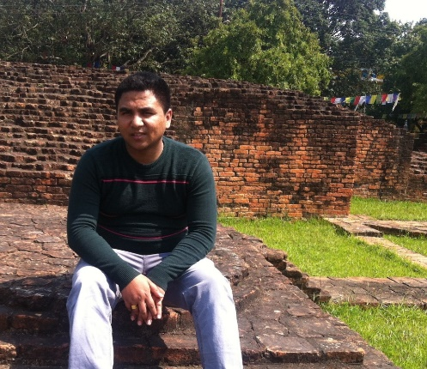

Panelist

Dev Bahadur Khadka

Co-Founder and CTO at SmartMobe Solutions

He has 7 Years of experience in software field, specializes in mobile technologies with multitude of platforms including android and iOS native, hybrid using Cordova and more.

Question:

Most developers identify themselves as Android Developers or iPhone Developers. Web app developers are now calling themselves hybrid mobile app developers. Aap kahan se aaye ho bhai?

As a company that is so mobile that it calls itself Smartmobe, how do you decide whether to go for a cross-platform or a native app? Do you think you’ll be building more hybrid apps than native apps a year down the line?

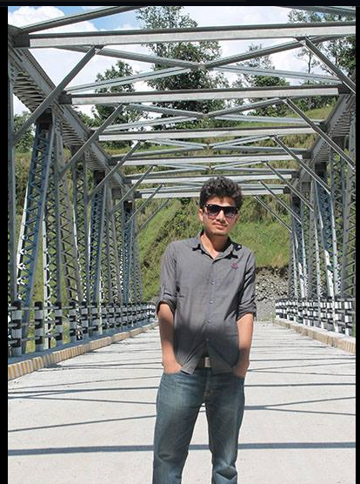

Piyush

Question:

There’s a lot of buzz around React-native and how it can change the mobile app development landscape.   
  
What do you think about it and what is the one thing that you would like to improve about it?

### About our sponsors - Toptal

Toptal connects the [**top 3%**](https://www.toptal.com/top-3-percent) of freelance designers and developers all over the world.

Toptal is not 100% remote. We gather on meetups, events, conferences, road-trips etc.

Screening process to understand you and make sure where we can fit you.

We also find good clients. We make sure the projects are interesting. We eliminate bad apples.

In every step of the process, no HR, no managers, all mentors are engineers and developers. Developers pick developers and developers pick clients.

Payment is guaranteed. No extra contracts and NDAs to be signed.

All projects we serve come from awesome startups and good clients to help you tap into American and West European markets which give you exposure to global market.

Separate team for matching talent with client

You have a human touch. Recruiter is always there. If you have any questions about the project, someone is always ready to

For developers by developers

One month of your life

Screening process itself makes you grow

People should practice for the screening process.

Take some part-time projects to do alongside your work. Get a taste of toptal. Understand the payment cycle, communication process.